Citizenship, Economics and Society (Secondary 1-3)
“3-minute Concept” Animated Video Clips Series:
“Personal Resource Management: Managing Finance”
Teaching Guidelines

1. Title of the animated video clip: “Personal Resource Management: Managing Finance”
2. Duration of the animated video clip: Around 3 minutes
3. Related CES Module: Module 1.3 Financial Education
4. Introduction of the animated video clip: The animated video clip was developed by the Personal, Social and Humanities Education Section, Curriculum Development Institute, Education Bureau. It uses daily examples and simple language to succinctly explain the concept of “Personal Resource Management”.
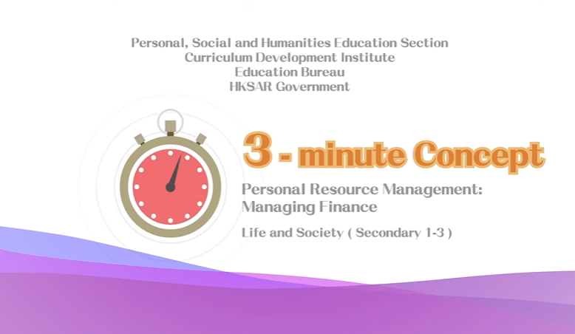
Citizenship, Economics and Society (Secondary 1-3)
Video link:
https://emm.edcity.hk/media/Life+and+Society+%223-minute+Concept%22+Animated+Video+Clips+SeriesA+%287%29+Personal+Resource+ManagementA+Managing+Finance+%28English+subtitles+available%29/1_7xrefilc
5. Teaching tips: Teachers must explain the following main points to students after playing the “Personal Resource Management: Managing Finance” animated video clip:
1) Work out a savings plan to cultivate the habit of saving | Teachers should emphasise to students that financial management is an important life skill and that good financial management habits should be developed from an early age. As students are still studying and have insufficient financial capacity, they should allocate and use their pocket money properly and should not spend it recklessly. Teachers should further point out to students that it is important to work out a savings plan to get into the habit of saving. When working out a savings plan, we should set clear savings goals, including the duration and amount of savings, etc. Teachers can advise students to start with short-term savings goals, and after accumulating successful savings experiences, they can move on to longer-term savings goals with higher target amounts to develop a long-lasting savings habit.
2) Adopt a rational attitude towards consumption and avoid overspending | Teachers should point out to students that in nowadays society, consumerism is prevalent and merchants will advertise their products through different media to attract consumers to buy their products. Eventually, consumers may make purchasing decisions not according to their actual needs or purchasing ability, which will easily lead to overspending. Teachers should further point out to students that overspending can easily lead to debt, which can cause significant financial and emotional stress (e.g., the stress brought by owing a debt). Teachers must emphasise to students that consumers should adopt a rational attitude towards consumption and distinguish between ‘needs’ and ‘wants’. Before spending, they should ensure that what they buy is what they ‘need’ to avoid making hasty or impulsive purchasing decisions. For a rational attitude toward consumption, please refer to the following resource:  Consumer Council - Guide to Consumer Rights and Responsibilities  https://www.consumer.org.hk/f/initiative_detail/301125/407069/2006100401e_v1.pdf
3) Not to believe too readily loan advertisements from financial institutions | Teachers should seriously remind students to carefully read and understand loan advertisements from financial institutions to avoid being misled. For example, some advertisements claim that no income proof is required and that loan applicants can easily apply for loans online. Teachers must emphasise to students that a borrower need to bear the responsibility of repaying the principal and interest on the loan, the cost of interest, the risk of being unable to repay the debts and the stress brought by owing a debt, etc. Teachers should further advise students that borrowing is a decision that needs to be carefully considered and that students should not take it lightly as they have not yet entered the workforce and lack repaying ability. At the same time, teachers should also remind students to be cautious of offers of making easy money to avoid unnecessary losses and even being used by criminals to break the law inadvertently.
4) Be aware of the potential risks and pitfalls of online shopping | Teachers should point out to students that as online shopping has become increasingly popular, they must be aware of the potential risks and traps, including the credibility of online shopping websites, security of payment methods, protection of personal data on the Internet and respect for intellectual property rights, etc. Teachers should further point out to students that online shopping is a more convenient and quicker consumption mode, which can easily lead to hasty or impulsive purchasing decisions. Teachers can advise students to carefully assess their purchasing power before making purchases on online shopping platforms, rectify the wrong conception of “spending future money” and avoid borrowing for consumption.

6. Consolidation questions: (See next page)

“3-minute Concept” Animated Video Clips Series:
“Personal Resource Management: Managing Finance”

Worksheet

A. Fill-in-the-blank questions
Put the correct answers in the boxes provided.
To practise saving, we should …

saving
- develop the habit of “ before spending”.

prices
- compare before making purchase decisions.

need
- arrange the priorities by putting things we

before things we want before purchasing.

expenditure
- keep a record of our income and , which will

help us to understand our spending pattern and remind ourselves to

avoid impulsive purchasing.

B. True or False
Study the following sentences about “Managing Finance”. Put a “T” in the blank for correct description and a “F” for incorrect description.
 | We should only buy the things we “need” and never buy the things we “want”. | F
 | The effect of “compound interest” is powerful, so it is good to start saving or investing as early as possible. | T
 | Since the interest cost for deferring credit card payments is very low, it is not a big deal to delay credit card payments frequently. | F

C. Put a short-term savings plan into practice

Our parents work hard for the family, and we should be filial and give back to our parents for their love and sacrifice. Let’s try to set a savings target to buy a small gift for your parents to express your gratitude. As the saying goes, “It’s the thought that counts”, the gift need not be expensive. It is more important to show your appreciation to your parents.

Savings target: | $ _______________________
Gift for parents:
Reason for choosing this gift:
Time for sending the gift:

The End

